41.26: For the 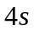 state,
Similarly, 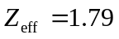 for the 4p state and 1.05 for the 4d state. The electrons in the states with higher l tend to be further away from the filled subshells and the screening is more complete.

